Field
# Source: AI Source: Provided by: [Data Path: Persons Table -> ID Column: 1, Name_En Column: Motasem Essam] -> From: [Chatgpt (GPT‑5 Mini)] on [1/26/2026]
In computing and data management, a field is the smallest unit of data in a record. It represents one specific piece of information about an item or entity.

Structure:
# Source: AI Source: Provided by: [Data Path: Persons Table -> ID Column: 1, Name_En Column: Motasem Essam] -> From: [Chatgpt (GPT‑5 Mini)] on [1/26/2026]
  - A record is made up of multiple fields.
  - Each field holds a single attribute or property of the record.

Example in a Student Record:
# Source: AI Source: Provided by: [Data Path: Persons Table -> ID Column: 1, Name_En Column: Motasem Essam] -> From: [Chatgpt (GPT‑5 Mini)] on [1/26/2026]
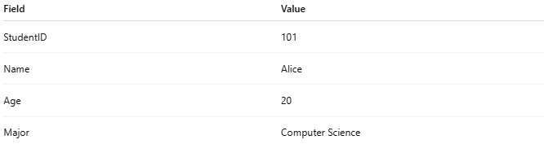
Field | Value
StudentID | 101
Name | Alice
Age | 20
Major | Computer Science
- Here:
  - StudentID, Name, Age, Major are fields.
  - 101, Alice, 20, Computer Science are the values stored in those fields.

Purpose:
# Source: AI Source: Provided by: [Data Path: Persons Table -> ID Column: 1, Name_En Column: Motasem Essam] -> From: [Chatgpt (GPT‑5 Mini)] on [1/26/2026]
  - Fields store individual pieces of data in an organized way.
  - They make it possible to search, sort, and process records efficiently.

Example in a CSV File:
# Source: AI Source: Provided by: [Data Path: Persons Table -> ID Column: 1, Name_En Column: Motasem Essam] -> From: [Chatgpt (GPT‑5 Mini)] on [1/26/2026]
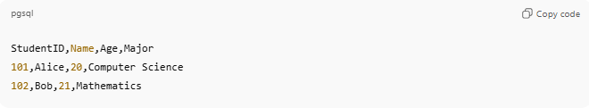
StudentID,Name,Age,Major
101,Alice,20,Computer Science
102,Bob,21,Mathematics
- Each column represents a field.
- Each row is a record.

💡 Analogy:
# Source: AI Source: Provided by: [Data Path: Persons Table -> ID Column: 1, Name_En Column: Motasem Essam] -> From: [Chatgpt (GPT‑5 Mini)] on [1/26/2026]
- File → Notebook
- Record → One page in the notebook
- Field → One line or item on that page

